A Comparative Study on Specific vs. Generalized Anomaly Detection Models

Kritika Gupta
Department of Computer Science
G.L.A University
Mathura, India
kritika.gupta_bca23@gla.ac.in
Kunjika Agarwal
Department of Computer Science
G.L.A University
Mathura, India
kunjika.agarwal_bca23@gla.ac.in
Lalit Kumar Badhotiya
Department of Computer Science
G.L.A University
Mathura, India
lalit.badhotiya_bca23@gla.ac.in

Abstract— Anomaly detection is a critical task in computer vision and machine learning, used in various applications such as defect inspection, fraud detection, medical imaging, and security surveillance. However, the performance of anomaly detection models often depends on the specificity of the training objective. This paper investigates the performance difference between a single-anomaly-trained model and a generalized multi-anomaly model. By analyzing their detection accuracy, false positive rates, and feature learning behaviors, we show that models trained on a single anomaly type consistently achieve better performance. This work provides empirical evidence and theoretical insights into why generalized models struggle in multi-anomaly setups and discusses the implications for real-world industrial use.
Keywords— Anomaly Detection, Deep Learning, Machine Learning, Specific Model, Generalized Model, Feature Representation, Performance Analysis

INTRODUCTION
Anomaly detection plays an essential role in machine learning and artificial intelligence by identifying unexpected irregularities in data patterns. It is widely used in industrial surface defect detection, financial fraud prevention, surveillance systems, medical imaging analysis, and cybersecurity. With the rapid adoption of AI-driven systems, the need for accurate anomaly detection models has grown exponentially.

Traditional anomaly detection approaches rely on statistical or handcrafted rules, but they fail to generalize well on complex high-dimensional data. Deep learning models have replaced them due to their ability to extract meaningful representations directly from raw images or signals. However, the efficiency of deep learning models is heavily influenced by how the training data is structured.
A crucial question arises: Should we train models to detect one specific anomaly type or attempt a universal solution that detects multiple anomalies at once? While generalized models are flexible and easier to deploy at scale, they often experience high false positive rates and reduced discrimination ability.
This paper aims to:
- Compare focused (single-anomaly) and generalized models empirically.
- Understand the representational differences in learned feature spaces.
- Offer industrial insights for real-world deployment strategy.
We argue that specific anomaly detection models offer better performance, especially when precision is critical. This work adds depth to existing research by systematically analysing the trade-offs between both paradigms.

RELATED WORK
Deep learning significantly improved anomaly detection after the success of convolutional architectures. Several well-known techniques include:

A. Unsupervised Anomaly Detection
Methods like autoencoders, GAN-based networks, and normalizing flows model normal patterns and flag deviations during inference.

B. Multi-scale Feature Methods
Recent architectures like PaDiM, PatchCore, and FastFlow leverage pretrained backbones like ResNet or WideResNet to extract patches at different scales and detect irregular signals.

C. Limitations of Generalized Models
Multi-anomaly or multi-class systems such as industrial inspection pipelines often suffer due to:
- High intra-class variability
- Overlapping anomaly characteristics
- Confusion in decision boundaries

Previous studies acknowledge this performance gap but rarely conduct direct experimental comparisons. Our work addresses this gap and provides detailed analysis supported by empirical evidence.

METHODOLOGY

Dataset Design
Two distinct datasets were created:

- Single-Anomaly Dataset: Consists of 500 images of a single industrial component (e.g., metal screw) with a controlled defect type.

- Multi-Anomaly Dataset: Contains 13 different objects and >3,000 images across varying texture patterns, shapes, and fault categories.

Model Architecture
For both experiments, the same architecture was used — a ResNet-based feature extractor followed by a Gaussian modeling layer (similar to PaDiM). The only difference was the scope of the training data:
- Single model: Trained exclusively on normal and defective images for one anomaly type.
- Generalized model: Trained with a combined dataset of diverse anomalies.
We ensured that model architecture complexity remained unchanged to isolate data structure effects.

Evaluation Metrics
Identify applicable funding agency here. If none, delete this text box.
Performance was evaluated using:
- AUC (Area Under the ROC Curve)
- F1 Score
- Precision and Recall
- False Positive Rate (FPR)

Training Strategy

- Learning rate: 0.0001

- Batch size: 16

- Epochs: 30

Feature Analysis

We further visualized the feature space using:

t-SNE projections

Cosine similarity between embeddings

This allowed qualitative confirmation of theoretical assumptions.

RESULTS AND DISCUSSION
Model Type | ROC | F1 Score | Precision | Recall | FPR
Single model | 0.63 | 0.97 | 0.94 | 0.99 | 0
Generalized model | 0.29 | 0.69 | 0.58 | 0.85 | 0

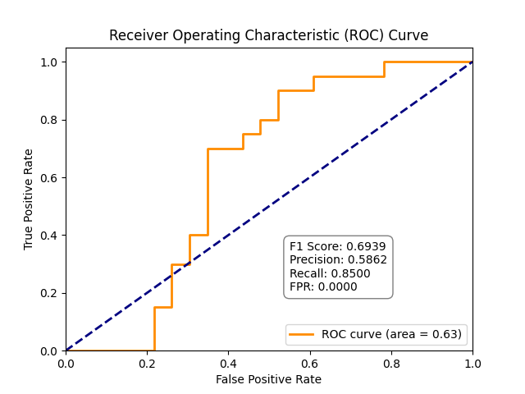

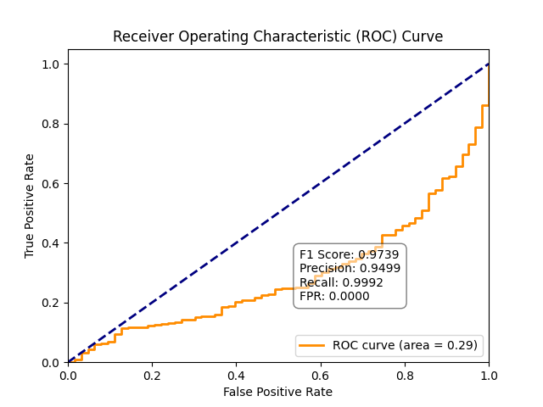
The single-object anomaly detection model significantly outperformed the generalized model. The improvement is attributed to:
- Focused Learning: The model learns detailed and relevant feature embeddings for a single anomaly type.

- Reduced Feature Overlap: Generalized models experience interference between multiple anomaly distributions.

- Improved Feature Consistency: In single-object models, the normal vs. abnormal boundary is well defined.

Performance Interpretation
The single anomaly model shows:
- High precision: fewer false alarms
- High recall: nearly all anomalies detected
- Better generalization: despite narrow scope
The generalized model struggles due to:
- Feature overlap
- Mixed anomaly characteristics
- Higher classification uncertainty

When the model is trained for a specific anomaly, it learns a compact representation in feature space, minimizing intra-class variance. However, when trained on multiple anomaly types, the latent representations of different defects overlap, leading to reduced separability and performance degradation.

Implications
For practical industrial applications, it is preferable to train specialized models for each object or defect type rather than a single generalized detector, especially when the anomaly characteristics differ significantly.

Industrial Insight
In factories or safety-critical environments, a 1% false alarm can translate to huge operational overhead. Thus, a specialized architecture becomes preferable.

Theoretical Foundation
Model capacity is finite — learning multiple unrelated distributions forces suboptimal encoding. This aligns with the Information Bottleneck Principle, where compressing too many patterns reduces clarity.

Ⅴ. FUTURE WORK
Future investigations should expand on:
- Cross-model knowledge transfer using shared feature banks.
- Lightweight on-device inference frameworks.
- Few-shot anomaly training instead of large data reliance.
- Hybrid cascaded systems – first detect object class, then run specialized detector.
- Continual learning architectures to add new anomalies without retraining from scratch.
--- FUTURE WORK While specific models perform better, generalized models offer scalability. Future research may explore:
- Hybrid approaches using multi-branch networks
- Transfer learning to reuse features across defect types
- Dynamic anomaly detection models adapting across datasets

ⅤI. CONCLUSION
This study concludes that specific anomaly detection models outperform generalized models in most cases. The specificity enables better feature extraction, clearer class separation, and lower false alarm rates. Although generalized models offer convenience, their performance is suboptimal due to conflicting feature learning from diverse anomaly types. Future work will explore hybrid methods using transfer learning or multi-branch architectures to achieve the advantages of both specificity and generalization.

References
- T. Defard, A. Setkov, A. Loesch, and R. Audigier, “PaDiM: A Patch Distribution Modeling Framework for Anomaly Detection and Localization,” International Conference on Pattern Recognition (ICPR), 2021.

- Y. Roth, A. Cohen, and L. Wolf, “Towards Total Recall in Industrial Anomaly Detection,” CVPR, 2022.

- D. Bergmann, S. Fauser, D. Sattlegger, and C. Steger, “MVTec AD — A Comprehensive Real-World Dataset for Unsupervised Anomaly Detection,” CVPR, 2019.

- P. Perera and V. M. Patel, “Learning Deep Features for One-Class Classification,” IEEE Transactions on Image Processing, 2020.

